Dev: AAbitew
Course: BIDD 330 – Business Intelligence & Data Design
Date: 04/12/2026

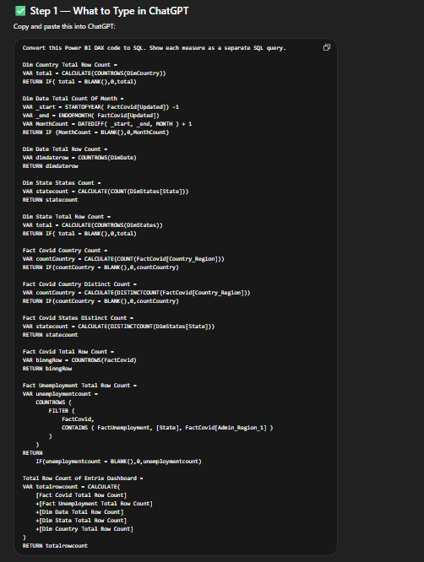

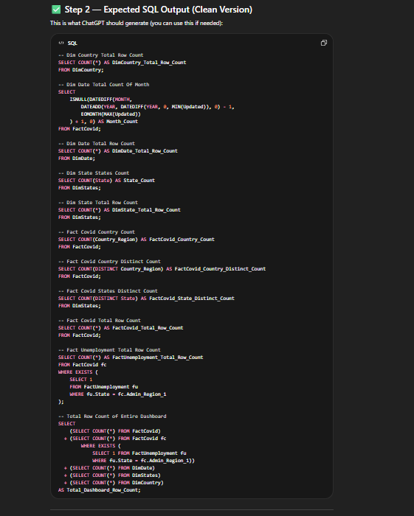

SQL Output on SQL on Management Studio

-- Dim Country Total Row Count
SELECT COUNT(*) AS DimCountry_Total_Row_Count
FROM DimCountry;

-- Dim Date Total Count Of Month
SELECT
ISNULL(DATEDIFF(MONTH,
DATEADD(YEAR, DATEDIFF(YEAR, 0, MIN(Updated)), 0) - 1,
EOMONTH(MAX(Updated))
) + 1, 0) AS Month_Count
FROM FactCovid;

-- Dim Date Total Row Count
SELECT COUNT(*) AS DimDate_Total_Row_Count
FROM DimDate;

-- Dim State States Count
SELECT COUNT(State) AS State_Count
FROM DimStates;

-- Dim State Total Row Count
SELECT COUNT(*) AS DimState_Total_Row_Count
FROM DimStates;

-- Fact Covid Country Count
SELECT COUNT(Country_Region) AS FactCovid_Country_Count
FROM FactCovid;

-- Fact Covid Country Distinct Count
SELECT COUNT(DISTINCT Country_Region) AS FactCovid_Country_Distinct_Count
FROM FactCovid;

-- Fact Covid States Distinct Count
SELECT COUNT(DISTINCT State) AS FactCovid_State_Distinct_Count
FROM DimStates;

-- Fact Covid Total Row Count
SELECT COUNT(*) AS FactCovid_Total_Row_Count
FROM FactCovid;

-- Fact Unemployment Total Row Count
SELECT COUNT(*) AS FactUnemployment_Total_Row_Count
FROM FactCovid fc
WHERE EXISTS (
SELECT 1
FROM FactUnemployment fu
WHERE fu.State = fc.Admin_Region_1
);

-- Total Row Count of Entire Dashboard
SELECT
(SELECT COUNT(*) FROM FactCovid)
+ (SELECT COUNT(*) FROM FactCovid fc
WHERE EXISTS (
SELECT 1 FROM FactUnemployment fu
WHERE fu.State = fc.Admin_Region_1))
+ (SELECT COUNT(*) FROM DimDate)
+ (SELECT COUNT(*) FROM DimStates)
+ (SELECT COUNT(*) FROM DimCountry)
AS Total_Dashboard_Row_Count;

